**Batch: B-1 Roll No.: 16010122104**

**Experiment / assignment / tutorial No. 7**

|  |
| --- |
| **TITLE:** Implementation of FIFO Page Replacement Algorithm |

**AIM:** The FIFO algorithm uses the principle that the block in the set which has been in

for the longest time will be replaced.

______________________________________________________________________ **Expected OUTCOME of Experiment: (Mention CO/CO’s attained here)** ___________________________________________________________________

**Books/ Journals/ Websites referred:**

1. Carl Hamacher, Zvonko Vranesic and Safwat Zaky, “Computer Organization”,

Fifth Edition, TataMcGraw-Hill.

2. William Stallings, “Computer Organization and Architecture: Designing for

Performance”, Eighth Edition, Pearson.

3. Dr. M. Usha, T. S. Srikanth, “Computer System Architecture and Organization”,

First Edition, Wiley-India

_____________________________________________________________________

**Pre Lab/ Prior Concepts:**

T he FIFO algorithm uses the principle that the block in the set which has been in the

block for the longest time is replaced. FIFO is easily implemented as a round robin or

criteria buffer technique. The data structure used for implementation is a queue. Assume

that the number of cache pages is three. Let the request to this cache is shown alongside.

**Algorithm:**

1. A hit is said to be occurred when a memory location requested is already in the cache.

2. When cache is not full, the number of blocks is added.

3. When cache is full, the block is replaced which was added first

**Design Steps:**

1. Start

2. Get input as memory block to be added to cache

3. Consider an element of the array

4. If cache is not full, add element to the cache array

5. If cache is full, check if element is already present

6. If it is hit is incremented

7. If not, element is added to cache removing first element (which is in first).

8. Repeat step 3 to 7 for remaining elements

9. Display the cache at very instance of step 8

10. Print hit ratio

11. End.

**Example:**

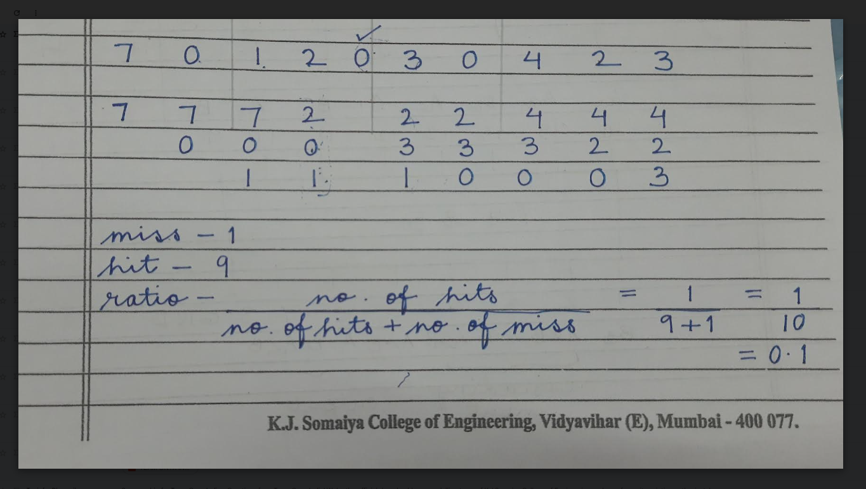

**Post Lab Descriptive Questions**

1. **What is meant by memory interleaving?**

**Ans:**

[Memory Interleaving](https://www.geeksforgeeks.org/memory-interleaving/) is an abstraction technique which divides memory into a number of modules such that successive words in the address space are placed in the different module.

**2. Explain Paging Concept?**

**Ans:**

Paging is a function of memory management where a computer will store and retrieve data from a device's secondary storage to the primary storage. Memory management is a crucial aspect of any computing device, and paging specifically is important to the implementation of virtual memory.

**Conclusion:** We learned the implementation of FIFO Page Replacement algorithm.

**Date: 27/09/2023**